Non Paper – A soft price collar for the European carbon market

So far, the European carbon market has successfully fulfilled its role to cap almost half of the European Union’s GHG emissions. However, the transition to a low carbon economy is both a climate necessity and an opportunity to create economic activity and jobs.
This "green growth" would result in particular from an acceleration of low-carbon investments and an improvement in purchasing power through improved energy efficiency which reduces energy bills. The realization of these opportunities faces today:
- a low carbon price in the European carbon market: the price of allowances has lost more than 40% of its value since the end of 2015 and its price is currently around 5 €;
- strong uncertainties regarding carbon price evolution. This structural volatility stems from the inability to anticipate changes in actual emissions for 2020 and 2030, and thus to measure the effort needed to achieve European goals in a long-term trajectory. Insofar as most low-carbon investments are long-term investments, the "market design" of the current EU ETS market is not sufficient to trigger investments.
Consequences are many: loss of attractiveness for investments in renewable energy and energy efficiency, increased cost in support mechanisms for renewable energy, weak government revenues from the auctions while these revenues usually fund the energy transition.
The establishment of a soft price collar for the European carbon market, to channel the evolution of the market price between a minimum and a maximum, would reduce volatility due to adverse expectations of future emissions and improve predictability of the price carbon, creating a strong incentive in favor of low-carbon investments and securing revenues for member states.
The price corridor could easily be set up based on the market stability reserve, and would not have a significant impact on the cumulated Member States auction revenues. Moreover, to avoid impacts on the competitiveness, the implementation of this soft price collar would be done in conjunction with maintaining improved and strengthened provisions to fight against a potential risk of carbon leakage.
It is also necessary to ensure the proper coordination of all the European climate and energy framework instruments with the ETS market and the price of carbon, to ensure the best efficiency.
Information contained in this paper aim at generating discussions and France is open to all Member States’ comments to improve this proposal toward a European carbon market that would be less volatile, more predictable, and more able to trigger the low-carbon investments which the European Union needs.
    - Why a minimum price floor for the European carbon market?
A floor price (reserve price at auctions) for the European carbon market is a signal to economic actors to foster investments. It provides visibility to investors and enables them to reduce the risk associated with current uncertainties on the level of future prices:
- Today, economic actors need to receive the right signals to trigger decisions for a transition to a low carbon economy;
- The current organization of the European carbon market and the effects of complementary policies in the EU climate and energy framework do not send a readable enough price signal to trigger the necessary investments;
- Establishing a minimum floor price for carbon allowances would secure a minimum and predictable incentive in the short and medium terms to reduce emissions and invest in low carbon technologies;
- This also reduces the risk for investments made by industries which know that the carbon price cannot collapse (as it has been the case in the past and in the current situation);
- The introduction of a price floor would trigger investments whose cost per avoided tons could be much higher than the price floor by creating a beneficial climate that would limit the risk aversion of investors.
    - Successful experiences of carbon markets operating with a minimum floor price for allowances
Several carbon markets in the world have right from the start set up a "minimum floor carbon price”, which may be accompanied by a "safety valve" in case of too high prices, thereby establishing a soft price collar.
In the United States, in California, for the nine states participating in RGGI carbon market, and Quebec, soft price collars have been established. In China, 7 pilot carbon markets indicate price control mechanisms more or less explicitly (annex).
    - Technical implementation of a soft price collar in the European carbon market
a) The device is divided into:
- An auction reserve price: the reserve price would evolve over time based on a predetermined trajectory to give visibility to the minimum price;
- A soft price ceiling: that evolves over time along a predetermined path to give visibility to the maximum price;
- A mechanism for adjusting the supply of allowances through auctions:
  - Allowances are placed in the reserve when the auction price is below the determined floor price;
  - Allowances are released through auctions (to the extent that allowances from the stock made previously are available) when the soft price ceiling is reached (this is a form of "safety valve");
  - This mechanism could be based on the existing market stability reserve by replacing its current criteria (surplus volume) for activation by a criteria based on allowance prices.
Figure 1- Functioning of soft price collar (minimum price and safety valve price)
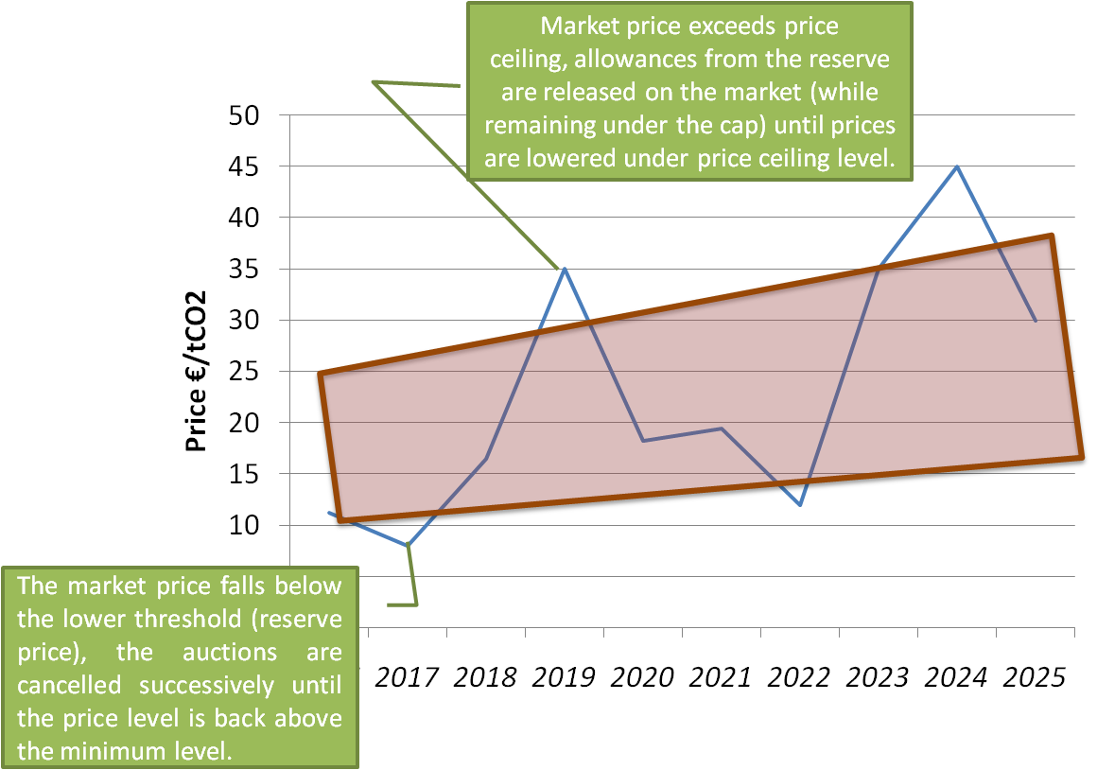
b) Definition of the auction reserve price
Several references, consistent with EU climate targets for 2030, are possible and would need to be discussed at European level:
- Based on the price projections following the decision concerning the market stability reserve (figure below, blue curve). This would secure minimum gains in terms of price which the consensus of economic actors hope to achieve from the market stability reserve;
- Based on a desired average carbon price level between 2021 and 2030 (figure below, grey curve). It would then be possible to aim for an average price of € 25 from 2021 to 2030 as in the impact assessment of the European Commission on the 2030 energy and climate framework;
- Based on the level of historical prices from 2013 to 2015 as a starting point and then increase every year by a certain percentage from 2016 as in North America (figure below, orange line). An increase of about 10% per year could lead to a price of 30 € in 2030.
Figure 2- illustrative examples of minimum carbon price trajectories
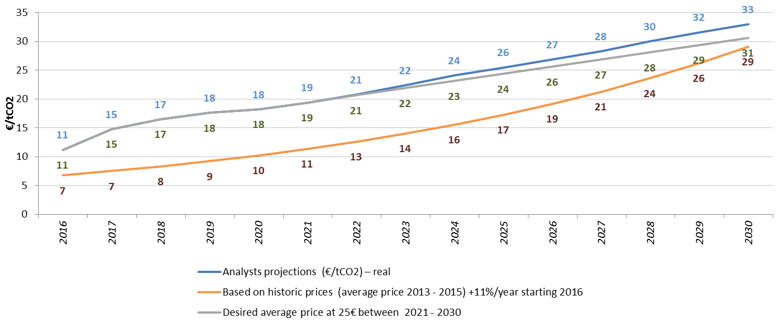
    - Impact of the soft price collar on auction revenues for Member States
The regulation mechanism within the collar should not have a significant impact on the accumulated auctioning revenues for Member States. Indeed, the loss of revenue due to a potential decrease in volumes (placed in the reserve) should be offset by prices maintained at least at the level of the reserve price (or higher). Indeed, the impact assessments on the market stability reserve and backloading, which are based on the same principle as the proposed soft price collar, showed that the price effect offsets the volume effect.
This mechanism could cause uncertainty about when auctioning revenues occur, but this risk can be mitigated: if the floor price path is close to the current projected path of price developments, it is likely that few auctions would be cancelled.
    - Impact of the soft price collar on industrial competitiveness
To avoid impacts on the competitiveness of the economy, the proposal for a soft carbon price collar needs to be necessarily accompanied by complementary measures to be implemented during the revision of the EU ETS:
- 100% free allocation to the most exposed sectors by targeting the most vulnerable sectors;
- A more harmonized and more effective system of compensation for indirect costs: France will make detailed proposals in this regard in a non-paper to come;
- The establishment of a carbon inclusion mechanism, starting with cement;
- A soft ceiling carbon price, which leads to establish a soft price collar;
- An acceleration of the implementation of the innovation fund to stimulate the development of low-carbon technologies in the European economy.

Annex: successful experiences of carbon markets operating with a minimum floor price for GHG allowances
Carbon markets | Minimum price per tCO₂ | Maximum price per tCO₂
California | In2015 : 12.10 USD [10.80 €] + (5 % + inflation) /year | In 2015: 45.20 USD, 50.86, and 56.51 [36.34 € - 45.43 €)+ (5% + inflation) /year*
Quebec | In 2015 : 12.08 CAD [7.80€] + (5% + inflation) /an | Convert from the Californian price ceiling**  In 2015 : 44.96 CAD, 50.58, 56.2 CAD [29 € - 36€]
RGGI | 2014 : 2.00 USD [1.78€]+ 2.5%/an | 2014 : 4.00 USD [3.56€] increasing to 10.77USD [9.61€] in 2020**
Beijing | Government can buy allowances on the market if the average carbon price during 10 days is lower than 20 yuan [2.7€] | Government can sell allowances on the market if the average carbon price during 10 days is higher than 150 yuan [20.7€]
Guangdong | CNY 25 [3.27 €] à CNY40 [5.24 €] + CNY5 [0.65 €] to each quarterly auction
South Korea |  | KRW 10 000 [7 €]
New Zealand |  | NZD 25 [16 €]
* To implement the soft ceiling price, allowances can be auctioned, if necessary, at a price ceiling fixed up to around 3-6 times the level of the auction reserve price.
** Maximum prices marked with a star are safety valves. Unlike a real price ceiling, they serve to reduce pressure to the temporary upward price by releasing allowances on the market from a pre-existing reserve. They therefore act under the emissions cap determined politically and do not undermine the environmental integrity of the system.
Source: Thomson Reuters et ICAP (last update 29/01/2016), I4CE

Impact assessments from the European Commission and from specialized analysts and investments companies.

